CCWD

Full Council Meeting

Coordinating Council for Workforce Development

In Person

Harper Auditorium,

631 Hampton St.

Columbia, SC 29201

Virtual Option

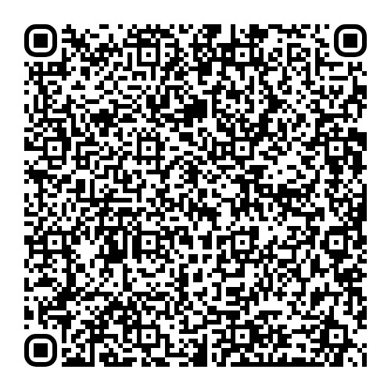

Meeting ID: 248 165 128 209

Passcode: U8kKhu

Welcome

Unified State Plan

Business Spotlight

Central Education & workforce portal

other business

Monday, June 17

10:00 am – 12:00 pm