CCWD

Full Council Meeting

Coordinating Council for Workforce Development

In Person

Harper Auditorium,

631 Hampton St.

Columbia, SC 29201

Virtual Option

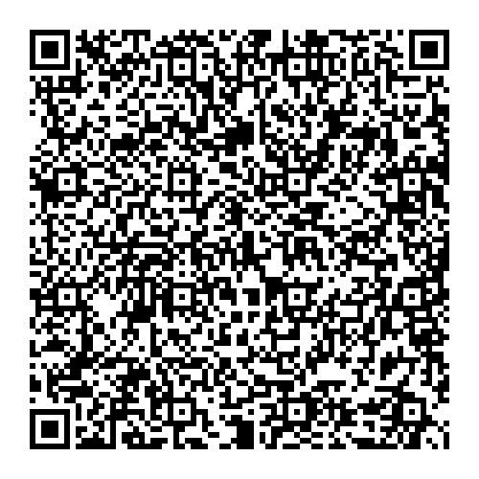

Meeting ID: 280 787 941 907

Passcode: PjTqL6

Welcome and Introductions

Research Spotlight

Business Spotlight

Committee and Other Project Updates

other business AND ADJOURNMENT

Monday, September 23

10:00 am – 12:00 pm