CCWD

Coordinating Council for Workforce Development

Interim Hub Information Session

Monday, January 13

3:00 – 4:00 pm

[Remote Teams Meeting](https://teams.microsoft.com/l/meetup-join/19%3ameeting_NDRlY2I0ZDgtNjY0OC00YmIxLTgzMWItMjcyMDZhYjBhMGQ2%40thread.v2/0?context=%7b%22Tid%22%3a%22ad59d44c-216e-4f89-8b7d-0a57cdbdf553%22%2c%22Oid%22%3a%22689b3f69-0910-40ec-9e14-063b9cf2451b%22%7d)

**Meeting ID: 280 326 503 513**

**Passcode: gx2sm2ox**

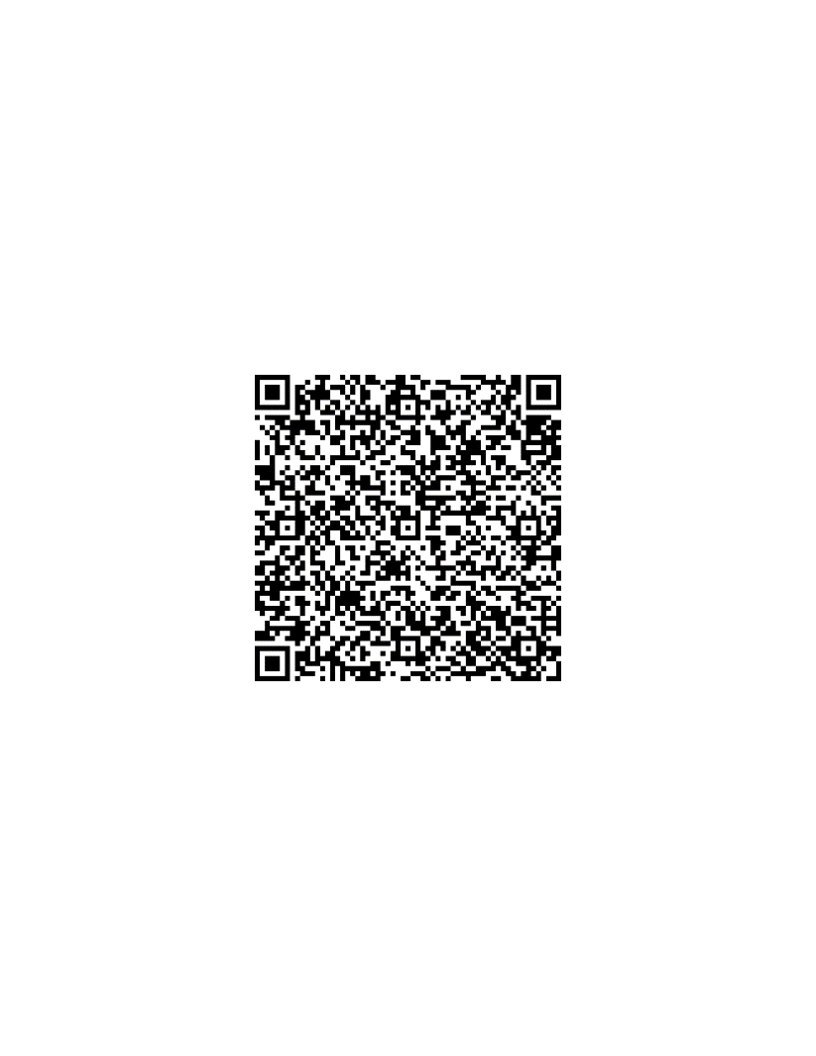

Find Your Future Platform (interim hub)

Personalization Pilot Tool on Find Your Future Platform