CCWD

Full Council Meeting

Coordinating Council for Workforce Development

In Person

Harper Auditorium,

631 Hampton St.

Columbia, SC 29201

Virtual Option

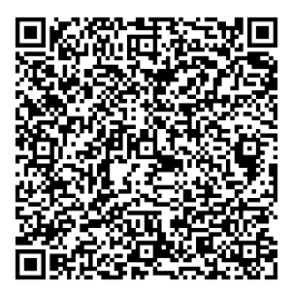

Meeting ID: 254 414 922 615

Passcode: gGgbtn

Welcome and Introductions

Business Spotlight (Hospitality)

Research Spotlight (Supply gap Analysis)

Committee Updates

Membership AND ADJOURNMENT

Monday, March 24

10:00 am – 12:00 pm