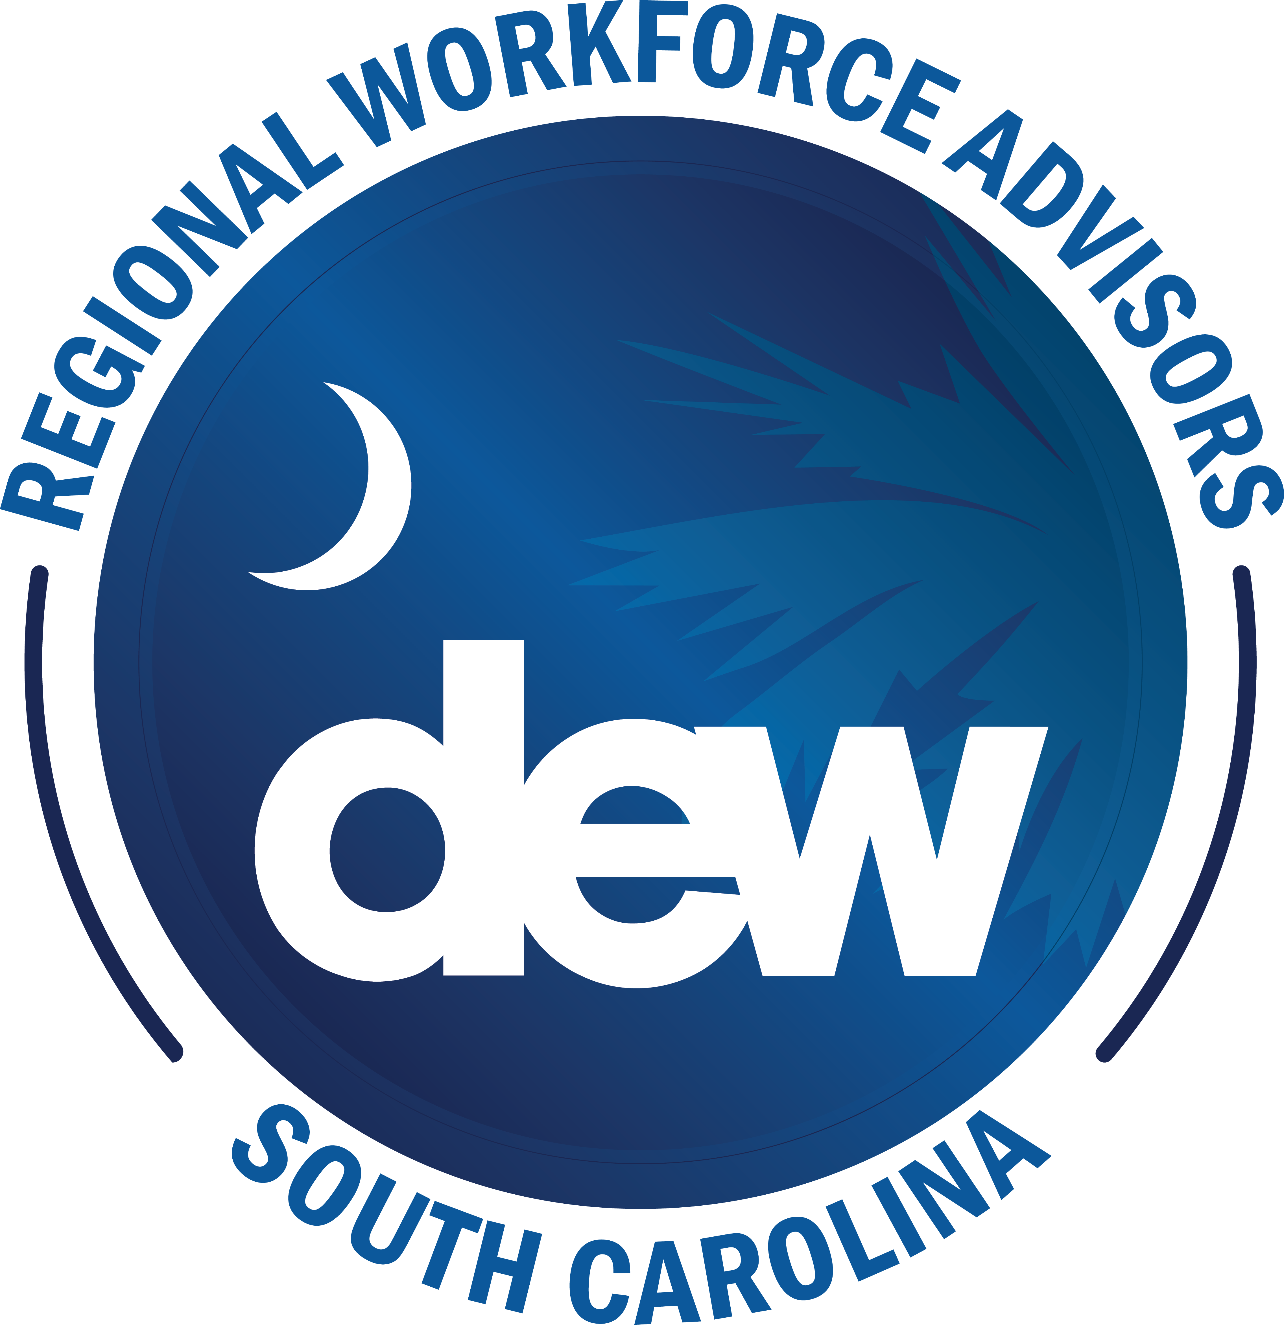
P.O. Box 995
1550 Gadsden Street
Columbia, SC 29202
dew.sc.gov
Greenville Region

Stacey McKinney
Regional Workforce Advisor

Greenville Region: RECAB
Thursday, April 24th, 2025
10-11:00 am

- Welcome/Introductions Stacey McKinney
Regional Workforce Advisor, SCDEW-Greenville

- RWA Report Stacey McKinney
RWA, SCDEW-Greenville
- JAN
  - Stueken Industry Tour (30 Students-Woodmont and Mauldin) -Will build in the fall
  - AJ Whittenburg Career Luncheons (2)-4th graders
  - Reedy River Church-Career Exploration Event
- FEB
  - AOP Showcase-Anderson
  - Legacy Parent Career Day -Career Day for parents of students at Legacy
  - Presentation with Level-Up Greenville
  - VR Days (Donaldson Career Ctr and Alternative Schools)
- MAR
  - College Fair at McAlister (Partnership with Jay) over 350 Students
  - Berea High and SHS High College and Career Fairs
  - Harbor Freight Fellows Summit (Day 1 and Day 2)
  - Health Science Day @ Seneca High and West-Oak Middle (VR’s)
  - Jankel Tech Systems industry tour (Fall- for Educators Day)
- APRIL
  - Career Day at Legacy (Mission Possible-Discover your Superpowers)
  - Workforce Utilities Summit at RE-WA
  - Woodmont High Career Day
  - Boeing Tour -63 Students from Hughes Academy
  - CTE Innovation Center (Partner Appreciation event)
- What’s NEW for Summer 2025 RECAB

- Educators in Industry tours (do more of these)
- STEM event(s)-
- Summer Camp(s)-Events to include tours, and onsite career days
- CMI Tours-Summer
- Carowinds(Carolinas Career Expo)-May 6th
- College & Career day in Columbia -May 7th

- Charleston Port Tour/Boeing Tour

- Wrap-up & Questions Stacey McKinney

